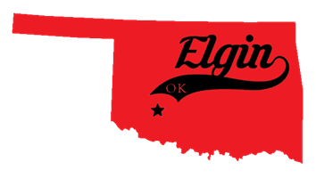
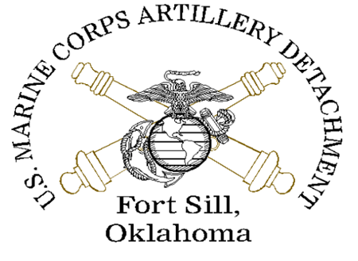
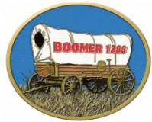

City of Elgin, The MARDET,
& The Marine Corps League
Present
Marine Corps Detachment Field Artillery School
29th Annual Devil Dog Run

10k Run, 5k Run and 1k Fun Run/Walk
September 10, 2022

We welcome your company to become a vendor or sponsor at the Marine Detachment Devil Dog Run! This is a great opportunity to open your business up to a whole new customer base. It also shows your customers your support of veterans and the Marine Detachment at Fort Sill.

As part of our overall promotional plan, press releases and news stories will be distributed to all Duncan, Lawton, Altus, Chickasha, Cache, Wichita Falls and other area media beginning about 20 days prior to the Devil Dog Run. They will also be posted to various web sites including Elgin Oklahoma website and Marine Detachment Facebook pages. More than three thousand promotional fliers will be printed and distributed all over Southwest Oklahoma.

Those companies that become event sponsors by August 5, 2022, will have their logo printed on all marketing material, including event T-shirts. So, the earlier you decide to join the better. We have many sponsorship levels to suit anyone’s budget.

Please keep in mind we cannot add your logo to any of our promotional materials without payment.

The Devil Dog Run will attract hundreds of runners and spectators from all over. The show is a family friendly event that will include food trucks, vendors, and music. Vendors come from all around Southwest Oklahoma!

PLATINUM SPONSOR: $1000

Your company’s logo on the front of 1000 promotional flyers.

Your company’s logo on 400 event shirts.

Your company’s logo will appear on our Facebook page, which is seen by thousands.

Your company’s logo will appear on promotional posters.

5 live announcements during the show featuring your company as a Gold Sponsor.

Your company name/logo appears on promotional materials as a participating sponsor.

10 x 20 vendor booth space at the show.

Inclusion of your company’s brochures and/or other form of advertising in our participant goody bags which are given to all participants.

Brochure, posters & T-Shirt all have a deadline for printing. Sponsorship must be paid in advance and deadline for printing is August 5, 2022.

GOLD SPONSOR: $750

Your company’s logo on 1000 promotional flyers.

Your company’s logo on 400 Devil Dog Run event shirts.

Your company’s logo will appear on our Facebook page seen by thousands.

Your company’s logo will appear on promotional posters.

5 live announcements during the show featuring your company as a participating Sponsor.

10x10 vendor booth space at the show.

Inclusion of your company’s brochures and/or other form of advertising in our participant goody bags which are given to the first 100 participants.

Brochure, posters & T-Shirt all have a deadline for printing. Sponsorship must be paid in advance and deadline for printing is August 5, 2022.

SILVER SPONSOR: $500

Your company’s logo on 1000 promotional flyers.

Your company’s logo on 400 Devil Dog Run event shirts.

Your company’s logo will appear on our Facebook website page seen by thousands.

Your company’s logo will appear on promotional posters.

3 live announcements featuring your company as a Silver Sponsor.

Your company’s logo appears on promotional material as a Participating Sponsor.

10x10 vendor booth space at the show.

Inclusion of your company’s brochures and/or other form of advertising in our participant goody bags which are given to the first 100 participants.

Brochure, posters & T-Shirt all have a deadline for printing. Sponsorship must be paid in advance and deadline for printing is August 5, 2022.

BRONZE SPONSOR: $250

Your company’s logo on 1000 promotional flyers.

Your company’s logo on 400 Devil Dog Run event shirts.

Your company’s logo will appear on our Facebook website page seen by thousands.

Your company’s logo will appear on promotional posters.

2 Live announcements during the show.

Your company’s logo appears on promotional material as a Participating Sponsor.

Brochure, posters & T-Shirt all have a deadline for printing. Sponsorship must be paid in advance and deadline for printing is August 5, 2022.

RAFFLE-GIVEAWAY DONATION SPONSOR: Donations

Raffle & Giveaway sponsor names will be announced as we draw the winner of each product. Donor names of higher valued goods will be announced periodically during the event itself.

29th Annual Marine Corps Detachment Devil Dog Run
September 10, 2022
SPONSOR AND VENDOR RESERVATION FORM

SPONSORS VENDOR SPACE FEE
Must be paid by August 5, 2022
Platinum $1,000 ___ 10 x 10 - $50___
Gold $ 750 ___ 10 x 20 - $100___
Silver $ 500___
Bronze $ 250 ___ NO ELECTRIC IS AVAILABLE!

Company Name________________________________________________

Contact Person_________________________________________________

Address_______________________________________________________

City_________________________________State_________Zip___________________________

Phone_______________Fax______________Email___________________

T-Shirt Pre-Order $15 per Shirt
Size________Quantity_______
Size________Quantity_______
Size________Quantity_______
Size________Quantity_______
PAYMENT INFORMATION: Payment must be paid to the Marine Corps League Boomer Detachment 1288

Check #_________
MC / Visa / Amex / Discover (circle one)
Card Number______________________Expiration Date________CVV___
Name on Card_________________________________________________

Payment can also be made at www.boomer1288.com.

PAYMENT: The full payment is a non-refundable registration fee for the selected space and is due with the submission of this agreement.

CANCELLATION OF SPACE: Application fees are not refundable. Marine Corps League Detachment 1288 is not liable if weather or other conditions prevent the Vendor from attending and fulfilling the contractual obligation as a Vendor. No refunds will be made for weather, accident, health, or other causes for non-participation.

INDEMNIFICATION: Exhibitor agrees to indemnify and hold harmless the Marine Corps League and the City of Elgin Oklahoma from and against any loss, expense, claims, damages, causes of action, injuries, suits or damages, suits to person or property, including attorney’s fees, arising out of, or related to being a Sponsor/Vendor at the 29th Annual Devil Dog Run.

We have the right to refuse entry.

Date_________________Signature_______________________________________________________

Make checks payable to: MCL Boomer 1288
Mail checks to: PO Box 3621 Lawton OK., 73502
If you want it picked up call 580-574-9744
Questions? Call David Hull MCL Boomer 1288 (580) 574-9744 (cell)

